CDBG Bid Notification Data Entry Form

Complete this Data Entry Form for each contract to be separately bid. E-mail the completed form(s) along with attachment(s) in MSWord or text form to: PTAC@ua.edu or ASBDC@ua.edu

Grantee Name:
Project Location:
Contact Person:
Phone number:
Email:
Address:
FSG:
NAICS: (if known)
Solicitation Number:
(if known)
Bid Closing Date:
Project Description:
Type/Quantity of Materials/Services Needed: (if Applicable)

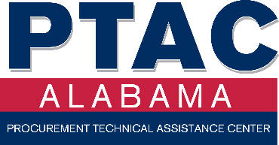
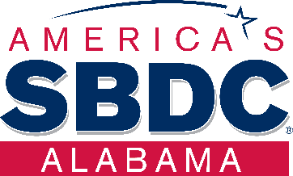
If electronic format isn’t available, mail this completed form to:
Alabama PTAC or Alabama SBDC Network
Attn: Procurement Program Manager
The University of Alabama
Box 870396, Tuscaloosa, AL 35487-0396
PTAC@ua.edu – ASBDC@ua.edu

